Hosting and Deployment

Supported OS

* Windows 7 and newer
* Windows server 2008 R2 and newer.

1. IIS Configuration:Enable the IIS role and establish role services

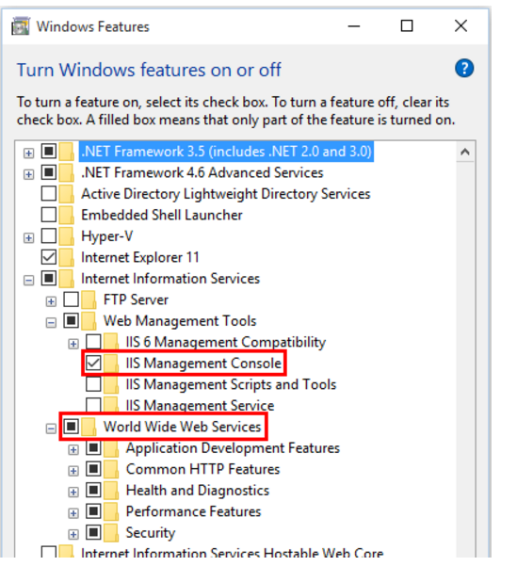

1. Install .NetCore Windows Server Hosting Bundle : This bundle will install the .net core runtime ,.net core library and ASP.Net Core Module. This module create reverse proxy between IIS and kestrel server.

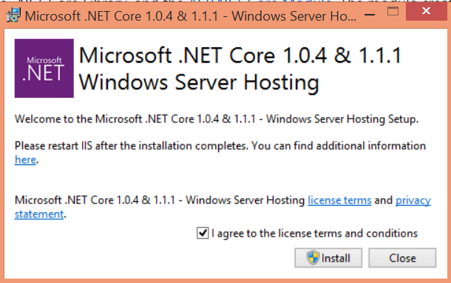

1. Pass net command to restart the services

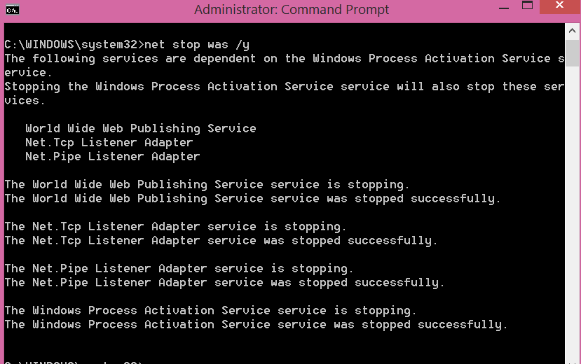

1. Install Web Deploy When Publishing with Visual studio Web Platform installer
2. Include Depedency on the AspNetCore.Server.IISIntegration Pacje in the application

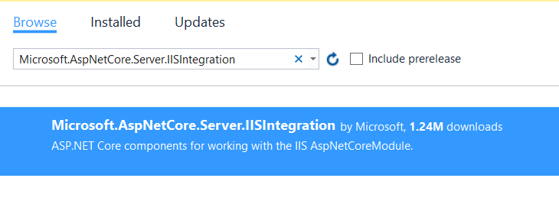

1. Enabling IIS integration Components . UseIISIntegration method will not impact the portability.

